1st Detective story
Yesterday at 11 am was murdered famous artist Bob Ross.
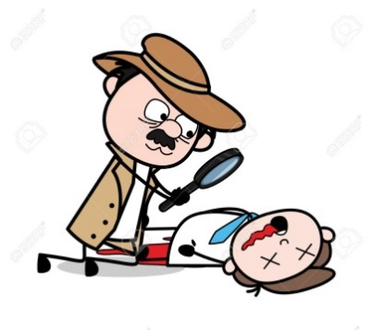
Detective had 4 suspicious. Bethany, John, Chloe and Dylan. Bethany, Bobs wife was in the living room playing piano. ,, I was playing when I heard a shot. I ran off to the hallway but didn’t see anything ,so I ran to the kitchen and saw John cooking meal. Then I went to the office and I saw Bob dead." Chloe the maid was cleaning. ,,I was cleaning bathroom upstairs ,but saw John through the window. He took something and went back." Dylan, the butler was in the dining room. ,,I was giving instructions to other people." And John, the chef was in the kitchen. ,,I was making spaghetti, but i needed some oregano so I went for it to the garden.Then when i came back Bethany was there saying I heard a shot." Detective also found in office a little piece of black fabric.
Who was it?
Wife Maid Butler Chef

Z.Mičietová, L.Pacík

2nd Detective story
It was 2 PM when the incident happened. John’s brother was outside helping to repair the car. Grandma and Mom were in the living room, watching TV. The household butler was in the kitchen preparing a meal for John and John, the victim, was in his library reading a book.
A gun was found on the table and near the table was an open window. Several hours later investigators also found several oilprints near the window, and on the gun.
The Butler went to take John’s coffee and saw him dead on the table. They immediatly called the police. Witnesses also reported a strange substance near the victims mouth, presumabely from some kind of poisonous reaction.
M.Michel, S . Ohrádka, M.Škuľavík

3rd Detective story
Murder in the house
Mrs Zuzanita Wilson, the owner of a luxury house, died yesterday. At half past eight in the evening there was a scream and Mrs Wilson was dead.
When I arrived, Mrs Wilson was in the living room. She layes on the floor surrounded by blood. I searched the room. The window to the garden was opened. There was a drop of blood on the window and trace of mud on the floor. There was nothing unusual in the other rooms.
In the evening, there were four people in the house: cook, gardener, maid and assistant Mrs Rossie. The gardener was outside and he was covered in mud. The cook was in the kitchen and he was cooking dinner. The maid was preparing Mrs Wilson´s bed for sleeping. Mrs Rossie was in the study arranging the summer vacation.
Who was the killer?

M.Pagáč, M.Lizoň, N.Tarabíková 8.A

4th Detective story

Murder in the house

One beautiful sunny day, James was murdered.
Someone shot a bullet into his head and robbed him. Police found three suspects from the house. The first was Donna she was doing laundry in the laundry room. The second was Gabriel he cut a tree in the garden. Third, Wilson was filled out with a paperwork. Police were lost, they haven’t known who the perpetrator was. They searched for clues. Only then they saw that Gabriel had a blood on his neck. The police arrested him immediately. He finally confessed to himself. The whole incident took place in the yard in front of the house.

T.Šedivý, N.Pavelčíková

1st – Dylan
2nd - John’s brother repairing the car
3rd - the gardener
4th - the answer is in the story

