Rihanna
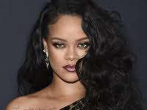
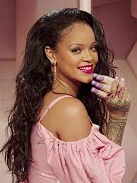
I decided this article will be about my favourite singer Rihanna because, in each of her songs are emotions that I like. She write about situations that happened to her and she inspired me a lot. Her real name is Robyn Rihanna Fenty, but she uses just her middle name she adopted-Rihanna. Rihanna was born on February 20, 1988 in Saint Michael but she grew up in Bridgetown. Her childhood was a difficult one as her father struggled with addictions to alcohol. Eventually, this led to her parents divorce when she was 14 years old. Before she become famous she had different career plans, but in the end she chose singing. Her fame started when her boyfriend introduced her to Evan Rogers. He was so surprised how talented she is, so they recorded together recordings. She has released 7 albums since then. Her life has changed a lot-from poor childhood to big fame.

